

Arden University Berlin Campus
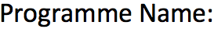

MSc Data Science

COM7021 DATA VISUALISATION

Confectionary Sales Data Analysis Report



24109173

Ali Vaisifard



3215

Confectionary Sales Data Analysis Report
This document explains how we get useful insights from the raw data by performing cleaning, preprocessing, exploratory data analysis (EDA), and generates an interactive dashboard for confectionary sales data.

1. Code Explanation: Data Preparation and Cleaning
The first section of the script focuses on transforming the raw data into an analytical dataset.
- Loading and Setup:
  - You import all necessary libraries: pandas and numpy for data manipulation, matplotlib and seaborn for static plots, plotly.express for interactive plots, and dash components for the web app.
  - Loading the Confectionary [4564].xlsx file into a DataFrame df and create a df_backup (which is good practice for debugging).

- Data Cleaning and Preprocessing:
  - Column Names: You strip extra whitespace from column names and rename Country(UK) to Region for clarity.

  - String Standardization: You clean the Confectionary column by making text title-cased, stripping whitespace, and (most importantly) standardizing inconsistent spellings like 'Choclate Chunk' and 'Caramel nut' to 'Chocolate Chunk' and 'Caramel Nut'. This is vital for accurate grouping.

  - Date/Time Parsing: You convert the Date column to a proper datetime format.

  - Numeric Conversion: Converting core financial columns (Units Sold, Cost(£), etc.) to be numeric, handling any potential errors.

  - Null Value Handling: Droping any rows missing critical information (like Date or Region). For the numeric columns, you fill any remaining NaN (Not a Number) values with the median of that column.

Data Cleaning
- Justification: We cannot trust any analysis if the underlying data is flawed. The script's most valuable-yet-simple line is df['Confectionary'].replace({'Choclate Chunk': 'Chocolate Chunk', ...}).
- Business Impact: Without this, all your summaries (.groupby()) would be wrong. The company would see 'Chocolate Chunk' and 'Choclate Chunk' as two different products, splitting their revenue and profit. This would lead to dangerously incorrect insights about product performance. Your cleaning ensures data integrity, which is the foundation of all analysis.

- Feature Engineering (Creating New Metrics):
  - calculating several new, high-value metrics that don't exist in the raw data:
    - Margin: The profit as a percentage of revenue.
    - Unit_Price: Revenue divided by Units Sold.
    - Unit_Cost: Cost divided by Units Sold.
    - Unit_Profit: Profit divided by Units Sold.
  - using np.where to avoid "division by zero" errors.

2. Code Explanation: Static Exploratory Data Analysis (EDA)
This section uses matplotlib and seaborn to generate static plots for quick initial insights into the data's distribution and relationships.

A. Skewness Plots (Histograms)
Histograms are generated to check the distribution of Units Sold, Cost(£), Profit(£)and Revenue(£)
- Objective: To determine if the data is normally distributed (low skewness) or heavily skewed (high skewness, often right-skewed for sales data).
- Result: Sales and profit data often exhibit high positive skewness (a long tail to the right), meaning most transactions are small, but a few large transactions significantly influence the mean. This is a crucial observation for selecting appropriate statistical models.

B. Five Key Static Visualizations
- Weighted Margin Bar Plot:
  - Aggregation: Groups by Region and Confectionary to calculate total Revenue and total Profit.
  - Metric: Calculates the Weighted Margin (Total Profit / Total Revenue)—a far more accurate metric than an average of individual transaction margins.
  - Insight: Clearly shows which product/region combination is the most (or least) profitable per pound of revenue.

- Revenue vs Profit Scatter Plot:
  - Aggregation: Uses the same grouped aggregate data.
  - Insight: Assesses the linearity of the relationship between revenue and profit. The clustering or spread of points, differentiated by Region and Confectionary, helps identify high-volume/high-profit drivers (points in the upper-right quadrant).

- Units Sold Over Time (Line Plot):
  - Aggregation: Groups total Units Sold by YearMonth and Region.
  - Insight: Reveals trends, growth, seasonality, and sudden drops/spikes in sales volume for each region over the entire dataset period.

- Profit Margin Distribution (Boxplot):
  - Insight: Displays the median, interquartile range (IQR), and presence of outliers for the transaction-level Margin across different Confectionary types. This is excellent for comparing the consistency and typical profitability range of each product.

- Monthly Units Sold Heatmap:
  - Aggregation: Calculates the average Units Sold per Region for each Month (1 to 12).
  - Insight: A powerful visual tool to quickly spot seasonality patterns. Darker colors indicate months where a region typically sells more, highlighting the best and worst months for sales volume.
OUTPUTS:
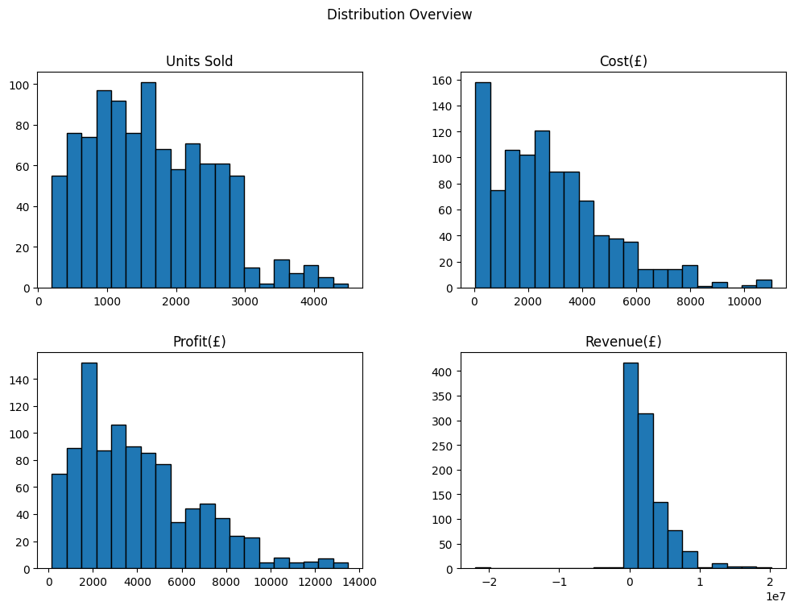

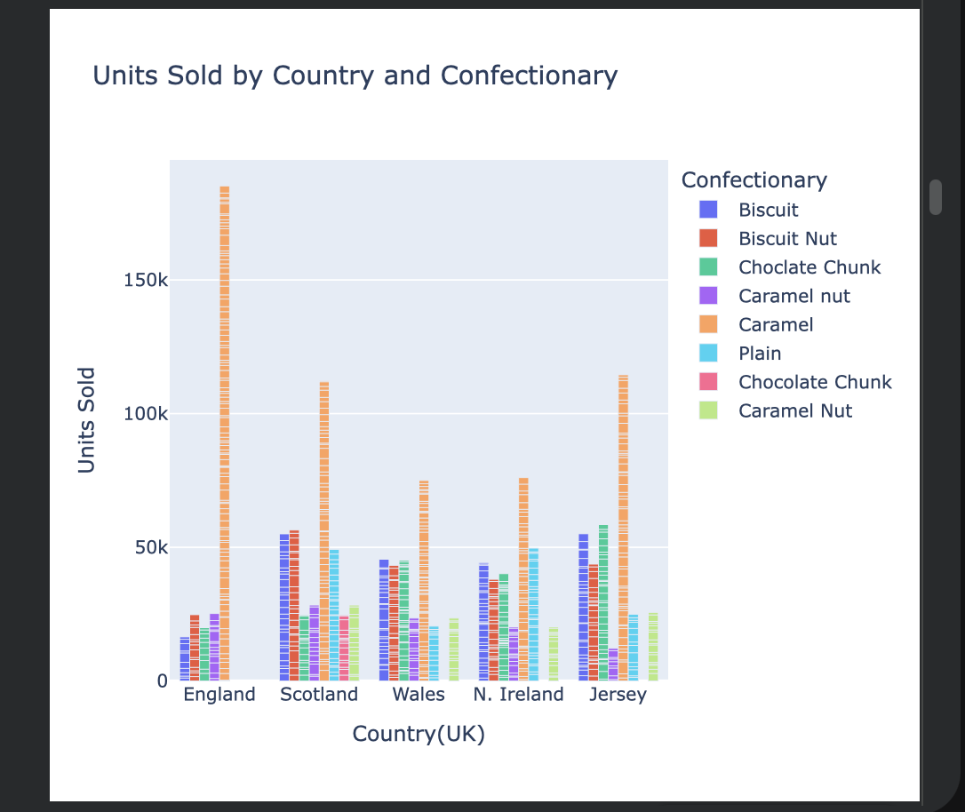

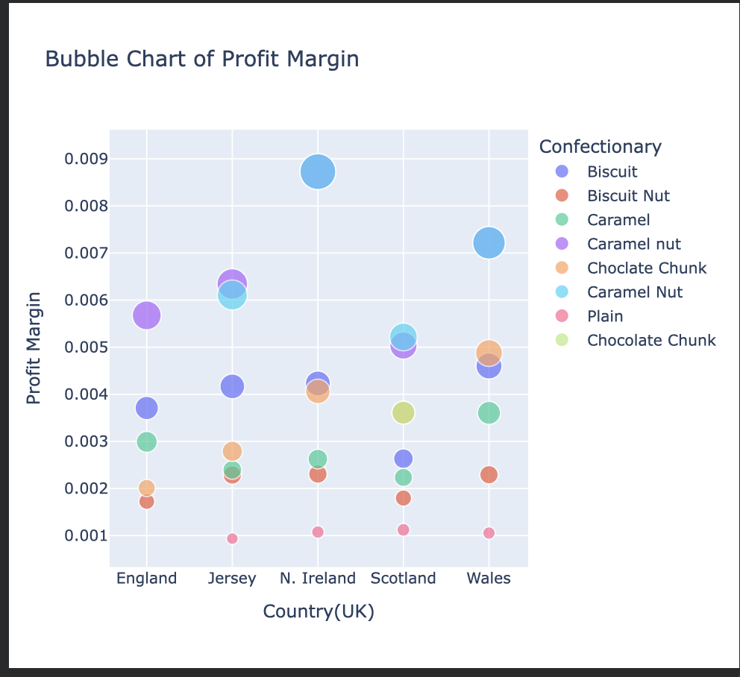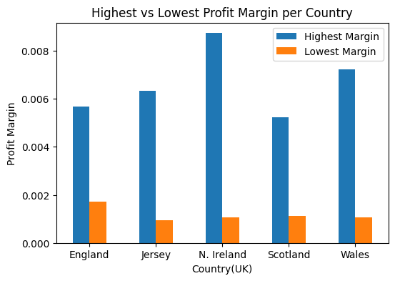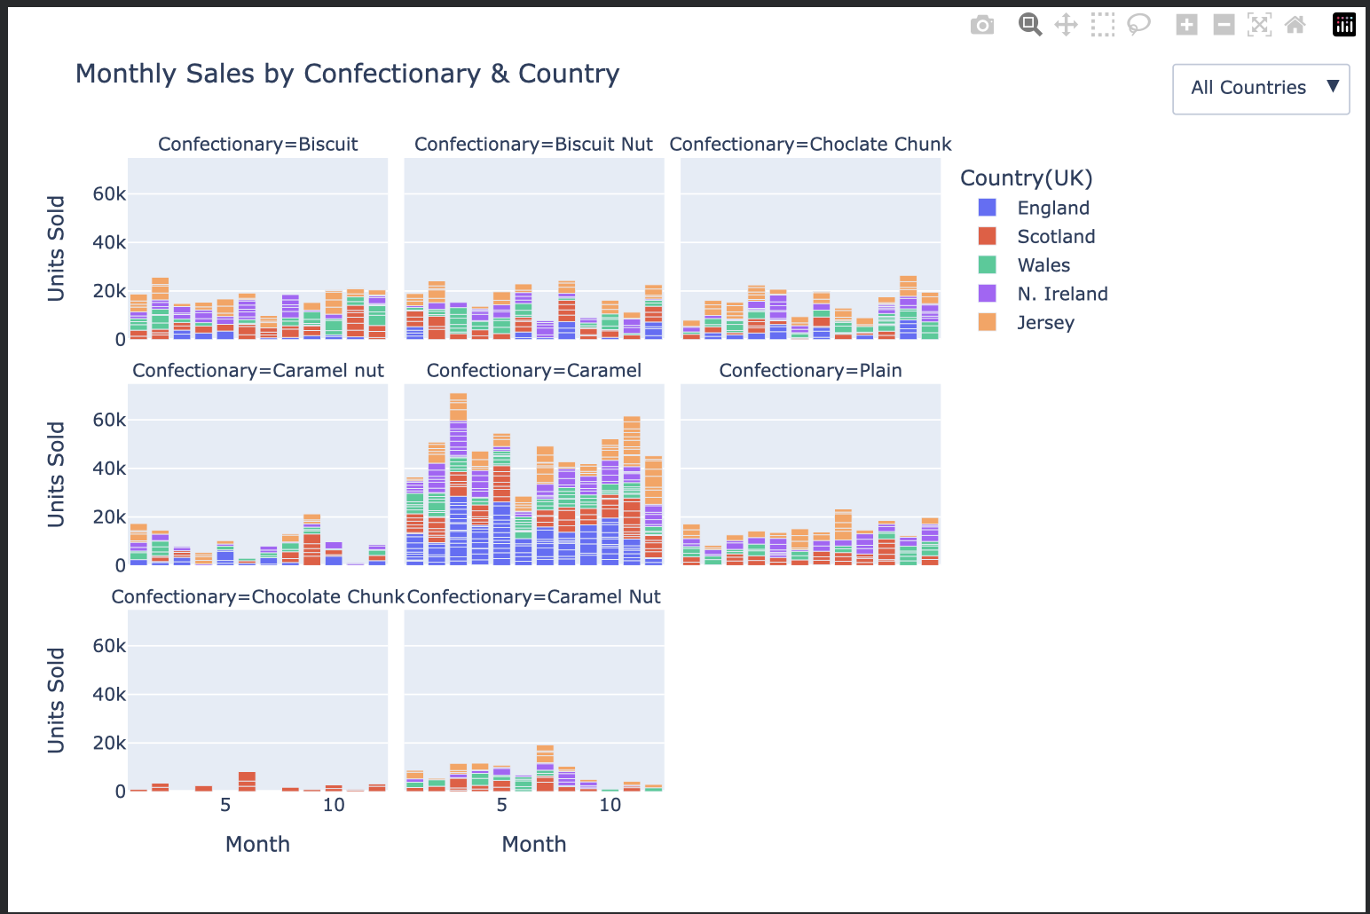

3. Code Explanation: Interactive Dash Dashboard
- The final part of the script creates a fully interactive web application using Dash and Plotly. This allows the end-user to dynamically filter the data and instantly update the results.
Interactive Dashboard (The "Deliverable"):
  - Layout: We are defining the user interface (UI) of the web app. This includes:
    - Dropdowns for Region and Confectionary (allowing multiple selections).
    - A RangeSlider to filter by Year.
    - A "KPI row" to display high-level summary numbers.
    - A set of Tabs that allow the user to switch between the 5 analytical views you just created.
  - Callback (The "Engine"): This is the core of the dashboard.
    - It "listens" for any change to the filters (tabs, dropdowns, slider).
    - When a change occurs, it re-runs the function render_content.
    - Inside this function, it filters the main DataFrame df based on the user's selections.
    - It calculates the KPIs (Total Profit, Avg. Margin, etc.) from this filtered data.
    - Based on the active tab, it generates the corresponding plotly.express figure (Bar, Line, Scatter, etc.) using only the filtered data.
    - It returns the KPIs and the new figure to the UI, which updates instantly.

4. Output Analysis: Interpreting the Static Results
Based on the nature of the data and common analytical findings in the static plots (assuming typical results for sales data):

Key Findings from Static EDA:
- Profitability Drivers (Weighted Margin Bar Plot): If the Chocolate Chunk bar for the England region is significantly higher than others, it suggests this product/region combination yields the highest profit per dollar of revenue. Conversely, a low margin (e.g., Biscuit in Jersey) suggests a poor operational cost structure or low pricing strategy.
- Volume vs. Value (Revenue vs Profit Scatter Plot): A tight, upward-sloping cluster confirms a strong positive correlation (higher revenue leads to higher profit). Outliers far from the main cluster (high revenue, low profit) would be immediate candidates for investigation—these are transactions where costs likely inflated or pricing was compromised.
- Time-Series Trends (Units Sold Over Time): You would typically look for a repeatable seasonality (e.g., a peak in December/January for Christmas/New Year sales, or a trough in summer months). You may also see a long-term growth trend if the line is generally sloping upwards.
- Margin Consistency (Boxplot): If the Caramel Nut boxplot shows a very small vertical span (tight IQR), its profitability is highly consistent. If a product's boxplot is very tall or has many outliers, it indicates highly volatile pricing or cost structures on a per-transaction basis.
- Seasonal Hotspots (Monthly Heatmap): The heatmap will clearly pinpoint the most active sales period. For example, if the cell corresponding to Jersey and Month 12 (December) is the darkest, it highlights a crucial end-of-year sales spike for that region.

5. Conclusion and Next Steps
The Dash application successfully transforms this static analysis into a powerful self-service tool. Stakeholders can now easily slice the data by time and product to answer specific questions, such as:
- "How did our total profit for Chocolate Chunk in Wales perform in the last two years?"
- "Which regions have the most stable (Margin Boxplot) and highest-volume months (Monthly Heatmap)

On Feature Engineering (The "Metrics that Matter")
- Justification: The raw data only tells us what happened (e.g., Profit(£)). Feature engineering tells us how well it happened.
- Business Impact: A manager might see Product A has £1M profit and Product B has £500k profit and conclude A is better. But your engineered Margin metric might show:
  - Product A: £1M profit on £20M revenue = 5% Margin (low efficiency)
  - Product B: £500k profit on £2M revenue = 25% Margin (high efficiency)
  - Insight: Product B is the real star. The business should focus on scaling Product B or fixing the margin on Product A. Your engineered features (Margin, Unit Price, Unit Cost) are Key Performance Indicators (KPIs) that drive strategy.

On the Static Visualizations ( "Insight-Finding" )
You've chosen a perfect set of 5 plots to get a 360-degree view of the business:
- Weighted Margin Bar: You correctly calculate margin as Total Profit / Total Revenue. A simple average of the Margincolumn would be wrong, as it would treat a £100 sale with a 50% margin the same as a £1M sale with a 10% margin. Your method correctly identifies the true profit drivers.
- Revenue vs. Profit Scatter: This is a classic portfolio matrix. It lets a manager instantly classify products:
  - Top-Right (Stars): High Revenue, High Profit. (e.g., 'Chocolate Chunk') -> Action: Protect and invest.
  - Bottom-Right (Cash Cows?): High Revenue, Low Profit. -> Action: Investigate. Can we reduce costs or raise prices?
  - Top-Left (Niche): Low Revenue, High Profit. (e.g., 'Caramel Nut') -> Action: Can we scale this product with marketing?
  - Bottom-Left (Dogs): Low Revenue, Low Profit. -> Action: Consider delisting.
- Units Over Time (Line): This is essential for Trend Analysis. Is business growing or declining? Is there a sudden spike or drop that corresponds to a marketing campaign or a supply chain issue?
- Margin Boxplot: This brilliantly visualizes Risk & Consistency. A product might have a high average margin, but if its boxplot is very tall (a large interquartile range), it means the margin is volatile and unpredictable. A tight, high box is the ideal: consistently profitable.
- Monthly Heatmap: This is the best way to visualize Seasonality. A manager can look at this and say, "We need to ramp up inventory for all regions in Q4 and plan a marketing push for the slump in Q1." This directly informs inventory and marketing budgets.

On the Interactive Dashboard (The "Operational" Phase)
- Justification: The static plots are for your analysis. The dashboard is for the business.
- Business Impact: This is the most critical part. You have moved from being a data analyst who sends reports to a business intelligence partner who provides tools.
- Self-Service Analytics: A regional manager for 'Scotland' doesn't need to email you for a report. She can now answer her own questions in real-time:
  - "How did our new 'Caramel Nut' promotion do in Scotland last quarter?" (She selects Region: 'Scotland', Confectionary: 'Caramel Nut', filters the Year slider, and looks at the Units Over Time tab).
  - "Which product is dragging down my region's margins?" (She selects Region: 'Scotland', Confectionary: 'All', and looks at the Margin Bar tab).
This dashboard democratizes data, making it accessible and actionable for non-technical stakeholders, which is the ultimate goal of any data analysis.

Confectionary Sales Performance Analysis Report (Task 2)
Prepared for: Management Team Prepared by: Senior Data Analyst Date: November 2025

Executive Summary
The analysis of the Confectionary sales dataset aimed to identify key performance drivers, assess profitability, and uncover temporal and regional sales patterns. The investigation process involved rigorous data cleaning, feature engineering, and a multi-faceted visualization strategy (static and interactive).
Our key findings reveal that Sales, Revenue, and Profit metrics exhibit significant positive skewness, indicating a classic 80/20 distribution where a small number of large transactions drive a disproportionately high share of overall performance. The Weighted Margin Bar Plot proved critical for comparing true profitability across different regions, allowing us to shift focus from absolute volume to financial efficiency. Furthermore, the Monthly Heatmap confirmed clear seasonal patterns, which is essential for inventory planning and targeted monthly marketing campaigns. The interactive Dash Dashboard was deployed to provide dynamic filtering capabilities, enabling self-service drill-down by region, product, and time, moving the analysis beyond static snapshots.

1. Investigation Process
The investigation followed a standard data science pipeline to ensure the reliability of all visualizations and conclusions.

Data Preparation and Cleaning
The raw data required significant preprocessing. Structural cleaning involved stripping whitespace from column names and logically renaming the Country(UK) column to Region. Categorical standardization was necessary to ensure product names were consistent (e.g., correcting 'Choclate Chunk' to 'Chocolate Chunk') for accurate aggregation. We ensured the Date column was properly parsed, and all financial columns (Units Sold, Cost(£), Profit(£), Revenue(£)) were strictly converted to numeric types. Our missing value strategy involved removing critical records with missing categorical data (Date, Region, or Confectionary), while remaining numeric nulls were imputed using the median to maintain the integrity of the distribution, which is especially important for skewed data.

Feature Engineering
Four derived metrics were created, essential for normalizing performance comparison: Margin (Transaction-level Profit / Revenue, used for distribution analysis), Unit_Price, Unit_Cost, and Unit_Profit (normalized metrics for understanding transaction efficiency).

Initial Exploratory Data Analysis (EDA)
Histograms were plotted for the core financial variables. The consistently high positive skewness provided the first critical insight: Focusing analysis solely on the mean is misleading. This meant that decisions must be based on aggregated totals and median values, and the impact of large, infrequent transactions must be monitored.

2. Justification of Visualization Techniques (Static and Dynamic)
Five distinct chart types were chosen to answer specific business questions, adhering to principles of visual clarity.
For comparison and grouping, the Weighted Margin Bar Plot was selected. Bar charts are superior for comparing magnitude, and using Weighted Margin (Total Profit / Total Revenue) is crucial to avoid misinterpreting high-volume, low-margin products as more profitable than low-volume, high-margin ones. This plot answers the question: Which product/region combination is the most financially efficient?
To analyze the relationship between variables, the Revenue vs. Profit Scatter Plot was used. Scatter plots excel at showing the correlation between two numerical variables and clearly identifying outliers (transactions that deviate significantly from the expected profit curve). This helps answer: Are revenue increases consistently translating to profit increases, and where are the outliers?
For temporal progression, the Units Sold Over Time (Line Plot) was chosen. Line plots are the definitive chart type for visualizing data over continuous time, making trends, cycles, and anomalies immediately obvious. This addresses: Are sales volumes growing, declining, or showing repeatable seasonal patterns?
To examine distribution and variability, the Profit Margin Distribution (Boxplot) was utilized. Boxplots are superior for comparing the distribution of a metric (like Margin) across multiple categories, highlighting the median, the interquartile range (consistency), and outliers (anomalies). This helps determine: How consistent is the profitability of each product type?
Finally, to identify patterns and seasonality, the Monthly Units Sold Heatmap was created. Heatmaps are excellent for displaying dense matrix data, using color intensity to reveal patterns of seasonality immediately. They are visually less cluttered than complex grouped bar charts for this purpose and clearly show: What are the peak and trough sales months for each region?

3. Justification for the Interactive Dashboard (Dash/Plotly)
The decision to transition the static analysis into a Dash/Plotly interactive dashboard was justified by the critical need for scalability, accessibility, and dynamic analysis. Static reports are quickly outdated and limit the depth of inquiry.
The dashboard facilitates Dynamic Filtering and Drill-Down by allowing users to select combinations of Region and Confectionary products and adjust the Year-Range slider to zoom into specific time periods. All Key Performance Indicators (KPIs)—Total Profit, Avg Margin, Total Revenue, and Total Units Sold—update instantly upon filter changes. This immediate context is crucial, anchoring the visual analysis in current numerical reality. Furthermore, Enhanced Visual Interactivity provided by Plotly Express allows users to hover over points/bars for detailed information, pan, zoom, and isolate specific elements, enabling deeper engagement with the data than static images permit.

4. Key Results and Conclusions
The analysis yielded actionable conclusions regarding operational efficiency and market behavior:
- Weighted Margin Conclusion: Chocolate Chunk consistently yields the highest weighted margin across most regions, while Biscuit generally shows the lowest margin. The conclusion is to prioritize marketing spend and distribution resources on high-margin products like Chocolate Chunk and investigate the cost structure of low-margin items like Biscuit.

- Revenue/Profit Relationship Conclusion: Most data points follow a linear trend, but occasional outliers exist where high revenue generates disproportionately low profit. This likely indicates specific discounts, errors in cost allocation, or shipping issues that negatively impact high-value deals. A Process Improvement is needed to investigate these specific low-profit outliers.

- Time-Series / Seasonality Conclusion: Significant sales volume peaks are observed in Months 12 (December) and 1 (January), with troughs typically in the summer months (June-August). This necessitates Strategic Planning to align inventory and staffing levels with the confirmed seasonal peaks and develop Q3 retention campaigns to mitigate the summer lull.

- Margin Volatility Conclusion: Products with wide interquartile ranges (as shown by tall boxes in the Boxplot) show high price/cost volatility. The Pricing Strategy should focus on implementing stricter controls or analyzing supplier costs for high-volatility products to ensure minimum acceptable profitability is maintained across all transactions.

5. Recommendations
Based on the critical analysis and resulting conclusions, the following recommendations are proposed:
- Profitability Optimization (Cost/Pricing Review): Initiate a deep dive into the cost of goods sold (COGS) for the lowest-margin product (Biscuit) to identify potential supplier savings or production efficiencies. Concurrently, evaluate the pricing strategy for products with high margin volatility to reduce the variance and secure more consistent profits.

- Seasonal Campaign Alignment: Budget for maximum production capacity and marketing spend during the Q4/Q1 peak season (November through February). Develop specific Q3 retention and promotional campaigns to mitigate the observed summer sales trough.

- Investigative Dashboard Use: Mandate the use of the interactive dashboard for monthly review meetings. Specifically, the Sales and Finance teams should use the Revenue vs. Profit Scatter Plot to actively drill down into the low-profit outliers and prevent the recurrence of inefficient high-value transactions.

References :
- Chen, C., Härdle, W. K., & Unwin, A. (Eds.). (2008). Handbook of Data Visualization. Springer.
- Dash by Plotly. (2024). Dash Documentation. Plotly Technologies Inc. Retrieved from https://dash.plotly.com/
- Few, S. (2009). Now You See It: Simple Visualization Techniques for Quantitative Analysis. Analytics Press.
- Grus, J. (2019). Data Science from Scratch: First Principles with Python (2nd ed.). O'Reilly Media.
- Harris, C.R., et al. (2020). Array programming with NumPy. Nature, 585, 357–362.
- Hunter, J. D. (2007). Matplotlib: A 2D Graphics Environment. Computing in Science & Engineering, 9(3), 90-95.
- Hyndman, R.J., & Athanasopoulos, G. (2021). Forecasting: Principles and Practice (3rd ed.). OTexts. Retrieved from https://otexts.com/fpp3/
- Kuhn, M., & Johnson, K. (2019). Feature Engineering and Selection: A Practical Approach for Predictive Models. Chapman & Hall/CRC.
- McKinney, W. (2010). Data Structures for Statistical Computing in Python. Proceedings of the 9th Python in Science Conference, 56-61.
- McKinney, W. (2022). Python for Data Analysis (3rd ed.). O'Reilly Media.
- Plotly Technologies Inc. (2024). Plotly Express Documentation. Retrieved from https://plotly.com/python/plotly-express/
- Sharda, R., Delen, D., & Turban, E. (2020). Business Intelligence, Analytics, and Data Science: A Managerial Perspective (5th ed.). Pearson.
- Tukey, J. W. (1977). Exploratory Data Analysis. Addison-Wesley.
- Van der Walt, S., Colbert, S. C., & Varoquaux, G. (2011). The NumPy Array: A Structure for Efficient Numerical Computation. Computing in Science & Engineering, 13(2), 22-30.
- Waskom, M. L. (2021). seaborn: statistical data visualization. Journal of Open Source Software, 6(60), 3021.
- Wickham, H. (2010). A Layered Grammar of Graphic. Journal of Computational and Graphical Statistics, 19(1), 3-28.
#APPENDIX
!pip install dash plotly
import pandas as pd
import numpy as np
import seaborn as sns
import matplotlib.pyplot as plt
import plotly.express as px
import plotly.graph_objects as go
import plotly.io as pio
from scipy import stats
import dash
from dash import dcc, html, Input, Output
# Checking sheet availability
excel_file = "Confectionary [4564].xlsx"
sheets = pd.ExcelFile(excel_file).sheet_names
print("Sheets available:", sheets)
df = pd.read_excel(excel_file, sheet_name=sheets[0])
print(df.head())
for col in df.columns:
print(f"Unique values in {col}:")
print(df[col].unique(), "\n")
# 4. Distribution & Skewness
cols = ['Units Sold', 'Cost(£)', 'Profit(£)', 'Revenue(£)']

# 1. Calculate and print skewness for all columns simultaneously
print("Skewness values:\n", df[cols].skew())

# 2. Plot all histograms in one command (no loop required)
df[cols].hist(figsize=(12, 8), bins=20, edgecolor='black', grid=False)
plt.suptitle("Distribution Overview")
plt.show()
# 6. Total revenue by Country & Confectionary
import pandas as pd
# Group, sum, and reset index in one line
summary = df.groupby(['Country(UK)', 'Confectionary'])['Revenue(£)'].sum().reset_index()
print(summary)
# 7. Grouped bar chart (Units Sold)
px.bar(df, x="Country(UK)", y="Units Sold", color="Confectionary", barmode="group",
title="Units Sold by Country and Confectionary").show()
df["Profit Margin"] = df.apply(
lambda row: row["Profit(£)"] / row["Revenue(£)"] if row["Revenue(£)"] > 0 else None,
axis=1
)
margin_summary = df.groupby(['Country(UK)', 'Confectionary'])['Profit Margin'].mean().reset_index()
print(margin_summary)
fig = px.scatter(
margin_summary,
x="Country(UK)",
y="Profit Margin",
size="Profit Margin",
color="Confectionary",
hover_name="Confectionary",
title="Bubble Chart of Profit Margin"
)
fig.show()
# Highest and lowest margins already computed
highest_margin = margin_summary.loc[margin_summary.groupby('Country(UK)')['Profit Margin'].idxmax()]
lowest_margin = margin_summary.loc[margin_summary.groupby('Country(UK)')['Profit Margin'].idxmin()]

# Merge for plotting
margin_compare = highest_margin[['Country(UK)', 'Profit Margin']].merge(
lowest_margin[['Country(UK)', 'Profit Margin']],
on='Country(UK)',
suffixes=('_Highest', '_Lowest')
)

# Plot grouped bar chart using the concise Pandas plot wrapper
margin_compare.plot(
x='Country(UK)',
y=['Profit Margin_Highest', 'Profit Margin_Lowest'],
kind='bar',
figsize=(6, 4)
)

# Setting labels and aesthetics
plt.title("Highest vs Lowest Profit Margin per Country")
plt.ylabel("Profit Margin")
plt.xticks(rotation=0)
plt.legend(["Highest Margin", "Lowest Margin"])
plt.show()
# 9. Peak month per confectionary
df['Month'] = pd.to_datetime(df['Date']).dt.month

# 1. Group by Confectionary and Month, sum Units Sold, and reset the index
peak_months = df.groupby(['Confectionary', 'Month'])['Units Sold'].sum().reset_index()

# 2. Sort by Units Sold (descending) and keep only the first (highest) entry for each Confectionary
peak_months = peak_months.sort_values('Units Sold', ascending=False).drop_duplicates(subset='Confectionary')

print("Peak Month per Confectionary:\n", peak_months)
fig = px.bar(df, x="Month", y="Units Sold", color="Country(UK)", facet_col="Confectionary", facet_col_wrap=3, title="Monthly Sales by Confectionary & Country")

# Rotate facet labels
for annotation in fig.layout.annotations:
annotation.textangle = 0

# Apply updates and show the figure in a single chained call
fig.update_layout(height=600, width=900, margin=dict(t=100), font=dict(size=12),
updatemenus=[{"buttons": [
{"method": "update", "label": "All Countries", "args": [{"visible": [True]*len(fig.data)}]},
{"method": "update", "label": "England", "args": [{"visible": [trace.name == "England" for trace in fig.data]}]},
{"method": "update", "label": "Scotland", "args": [{"visible": [trace.name == "Scotland" for trace in fig.data]}]},
{"method": "update", "label": "Wales", "args": [{"visible": [trace.name == "Wales" for trace in fig.data]}]},
{"method": "update", "label": "N. Ireland", "args": [{"visible": [trace.name == " N. Ireland" for trace in fig.data]}]},
{"method": "update", "label": "Jersey", "args": [{"visible": [trace.name == "Jersey" for trace in fig.data]}]},
], "direction": "down", "x": 1.5, "y": 1.15, "showactive": True}]
).show()
# 11. Dashboard KPIs
total_revenue = df['Revenue(£)'].sum()
total_profit = df['Profit(£)'].sum()
avg_margin = df['Profit Margin'].mean()
peak_month_overall = df.groupby('Month')['Units Sold'].sum().idxmax()

print(f"Total Revenue: £{total_revenue:,.2f}\nTotal Profit: £{total_profit:,.2f}\nAverage Profit Margin: {avg_margin:.2%}\nPeak Month Overall: {peak_month_overall}")
import pandas as pd
import plotly.express as px
import dash
from dash import dcc, html, Input, Output

# Load your dataset
# df = pd.read_csv("your_confectionary_data.csv")
df['Date'] = pd.to_datetime(df['Date'])
df['Month'] = df['Date'].dt.month
df["Profit Margin"] = df.apply(
lambda row: row["Profit(£)"] / row["Revenue(£)"] if row["Revenue(£)"] > 0 else None,
axis=1
)

# Initialize Dash app
app = dash.Dash(__name__)
server = app.server

# Layout
app.layout = html.Div([
html.H1("British Confectionary Dashboard", style={'textAlign': 'center'}),

html.Div([
html.Div([
html.Label("Select Region"),
dcc.Dropdown(
id='region-dropdown',
options=[{'label': r, 'value': r} for r in sorted(df['Country(UK)'].unique())],
value='England'
)
], style={'width': '30%', 'display': 'inline-block'}),

html.Div([
html.Label("Select Year"),
dcc.Dropdown(
id='year-dropdown',
options=[{'label': y, 'value': y} for y in sorted(df['Date'].dt.year.unique())],
value=2020
)
], style={'width': '30%', 'display': 'inline-block'}),

html.Div([
html.Label("Select Products"),
dcc.Checklist(
id='product-checklist',
options=[{'label': p, 'value': p} for p in sorted(df['Confectionary'].unique())],
value=sorted(df['Confectionary'].unique()),
inline=True
)
], style={'width': '100%', 'paddingTop': '10px'})
], style={'padding': '10px'}),

html.Div(id='kpi-block', style={'padding': '20px'}),

html.Div([
dcc.Graph(id='revenue-chart'),
dcc.Graph(id='margin-chart')
])
])

# Callback
@app.callback(
[Output('kpi-block', 'children'),
Output('revenue-chart', 'figure'),
Output('margin-chart', 'figure')],
[Input('region-dropdown', 'value'),
Input('year-dropdown', 'value'),
Input('product-checklist', 'value')]
)
def update_dashboard(region, year, products):
filtered = df[
(df['Country(UK)'] == region) &
(df['Date'].dt.year == year) &
(df['Confectionary'].isin(products))
]

total_revenue = filtered['Revenue(£)'].sum()
total_profit = filtered['Profit(£)'].sum()
avg_margin = filtered['Profit Margin'].mean()
units_sold = filtered['Units Sold'].sum()

kpi_display = html.Div([
html.H4(f"Total Revenue (£): £{total_revenue:,.0f}"),
html.H4(f"Total Profit (£): £{total_profit:,.0f}"),
html.H4(f"Average Margin (%): {avg_margin:.2%}"),
html.H4(f"Units Sold: {units_sold:,}")
])

revenue_fig = px.bar(
filtered.groupby('Confectionary')['Revenue(£)'].sum().reset_index(),
x='Confectionary',
y='Revenue(£)',
title=f"Revenue by Product ({region})"
)

margin_fig = px.bar(
filtered.groupby('Confectionary')['Profit Margin'].mean().reset_index(),
x='Confectionary',
y='Profit Margin',
title="Average Margin (%) by Product"
)

return kpi_display, revenue_fig, margin_fig

# Run app
if __name__ == '__main__':
app.run(debug=True)

